General features
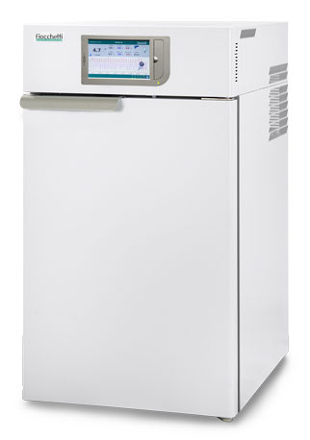  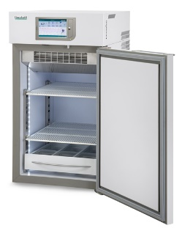  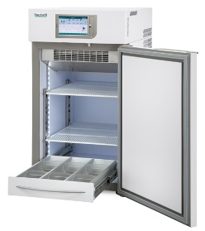  Disclaimer:  Images are purely indicative. The features and the accessories of the products may differ according to model and application. | Intended use | Refrigerator destined to store and preserve vaccines, pharmaceutical products, bacterial cultures, samples, analysis materials, chemical products, and other laboratory formulas, to support therapy and/or prevention in clinical centers, hospitals, pharmacies, and laboratories.
 | Temperature range | Adjustable -20°C / -10 °C
 | Factory setpoint | Increment | -20°C | 0.1°C
 | Ambient working class | Climatic class | From +16°C to +32°C | N
 | Nominal capacity | 140 lt (4,94 cu ft)
 | Gross capacity | Net capacity | 153 lt (5,40 cu ft) | 128 lt (4,52 cu ft)
 | External dimensions (WxDxH) | 52x63,5x93,5 cm
 | Internal dimensions (WxDxH) | 44x51,6x56 cm
 | Net weight without any internal fittings | 53 kg
 | Package dimensions | Weight | Cardboard on pallet 55x69x113 cm | weight 61,5 kg
 |  | Wooden crate on pallet 60x77x124 cm | weight 72,5 kg
 | Structure | Monocoque type body, made of plasticized, non-toxic white steel interior/exterior, coated with a special antibacterial-type film, or in inner 18/10 Aisi 304 stainless steel. Rounded corners and tray-type inner bottom.
 | Insulation type | High density (43 kg/m³) in-walls injected PUF, without any CFC, water-foam based.
 | Insulation thickness | 40 mm
 | Feet | No.4 adjustable small feet
 | Door | No.1 solid door with ergonomic handle, self-closing thanks to the spring hinge and 90°stop position.
 | Lightning | Full LED, all length of inner chamber, automatic switching on at door opening.
 | Energy saving functions | Night & Day function
 | Internal fittings | Customizable and height adjustable, it can mix independently:  wire shelves supported by adjustable clips (dim.cm.40x47)  fully extractible drawers made of aluminium, with dividers (WxDxH): cm 10x45x7,5 (nr 3 compartments)  fully extractible drawers made of aluminium, without dividers (WxDxH): cm 33x45x7,5
 | Suggested internal fittings | No. 2 wire shelves
 | Refrigeration system
 | Refrigeration | Professional, ventilated, forced, hermetic compressor type
 | Defrost | Automatic, adaptive, including condensate water vaporization
 | Refrigerant | Natural R290
 | GWP | ODP | 3 | 0

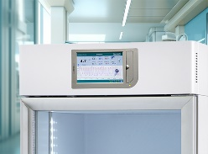 | Electronic controller
 | Controller | TOUCH controller
 | Type of controller | Electronic controller, FULL TOUCH SCREEN 7” display, resolution 0,1°C, easily readable from the distance, with a real time temperature graph and all operational data always available on the homepage.
 | Power switch | Integrated in user’s interface
 | Security features | Settable user password
 | Alarm system | Visual and acoustic for temperature alarms failures such as:  Open door  High temperature  Low temperature  Power failure, signaled when power is back.  Clogged condenser  Any functional failure/faulty parts
 | Data and event recording | Latest 32 events displayed, 10 years data recorded on SD card and 1 year on flash memory, downloadable from USB port
 | Settable temperature limits alarms | Yes
 | Control sensors | NTC type probes for controller board + PT100 for DMLP monitor board (optional)
 | Safety thermostat | Included, to prevent overheating
 | Connectivity for remote alarms transmission | Set-up on the electronic controller board, can be remoted on request.  Modbus TCP/IP protocol available for data reading
 | Temperature recording | Full recording of temperatures and alarms data
 | Data export | USB, SD and RJ45.
 | Electrical and functional data
 | Standard power supply | 230V / 1ph / 50Hz
 | Standard plug type | Schuko tipo “G”
 | Compressor protection | Overload Protector included
 | Power absorption/current | kW 0,5 (Amp 2,3)
 | Inrush current | Amp 6
 | Noise level | <40 dBA
 | Heat emission according to EN 12900 | W 155
 | Hold over time at 20°C ambient (air) | 1,6 h (from -20°C to 0°C)
 | Energy consumption at 20°C ambient | 3,7 kWh/24h
 | Compliancy
 | Directives and regulations | The offered unit complies with Regulation (EU) 2017/745 and subsequent modifications and integrations, Risk Class I (All. VIII, Cap. III, Reg. 2).  The equipment is also fully compliant with the specific requirements of the norms:  Directive 2006/42/EC (Machines Directive),  Directive 2014/30/EU (EMC),  Directive 2014/35/EU (LVD),  Regulation (EU) 2024/573 (F-gas),  Directive 2012/19/EU (RAEE)  Regulation (EC) n.1907/2006 (REACH)  Directive 2011/65/UE (ROHS II) including subsequent modifications and integrations
 | Available certificate | CE
 | Application environment | Non-flammable, non-explosive, non-corrosive, with adequate air exchange

Accessories available on request
Visual and acoustic alarm for power failure | No.8 rechargeable batteries, AA, Ni-MH type, environmental friendly and easily replaceable, to feed power failure alarm

External contacts (Ethernet+ potential free) terminal board
Electric-digital lock with password protection | Digital lock, the door is opened by touching an icon on the display. The function may be password protected. Mechanical release key supplied for emergency opening.
GSM module (including buffer batteries) | Plug-in module to notify on mobile phones, via sms, overall monitoring, alarms and failures of the refrigerator
Converter module type 4-20mA (including contacts terminal board) | External contacts included (this accessory excludes the installation of the GSM module)
Wi-Fi module | Plug-in module to connect to, monitor and manage the refrigerator wirelessly
Compliance kit to DIN 13277 | Includes the electric digital lock, buffer batteries for power failure alarm signal and the external terminal board with potential free contact
DMLP TOUCH Digital Monitor | Visual, acoustic alarm and fully independent recording system, with accuracy 0,1 °C thanks to the PT100 probes used for temperature detection. DMLP will take over alarming function when installed as integrated module on the Ect-f Touch controller board. The module is fed by standard rechargeable batteries (power failure alarm batteries included) to register temperatures and events even in case of power outage. Data download and their management are made possible by CAPTURE software, supplied on board on the SD card, through which tables and graphs are created

PT100 product temperature simulation probe
FIOCCHETTI COLD EYES cloud monitoring | Annual monitoring service, Cloud based, featuring the notification of alarms and failures from pc thanks to a dedicated app, including SMS messages and emails, also allowing the full download of recorded data.
FIOCCHETTI LAN SUPERVISOR | Monitoring system allowing the supervision of one or several refrigerators thanks to the access to historical data and to present equipment status. It allows the creation and export of temperature graphs of selected periods or of specific hours. A single license enables the connection of up to 100 refrigerators installed in the same building and connected to the same net (e.g., a hospital).

Additional wire shelf kit

Extractible drawer on telescopic slides

Extractible drawer without inner dividers on telescopic slides

Plexiglas front panel for extractible drawer

One-way small castors

Castors kit with brakes

35 mm access port with stopper

Port hole mm 15

PT100 sensor with free contacts

Mains voltage stabilizer

Non-standard plug and cable

Power 220V/60Hz

Power 115V/60Hz

Wooden crate package

