General features
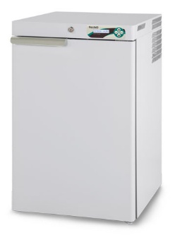  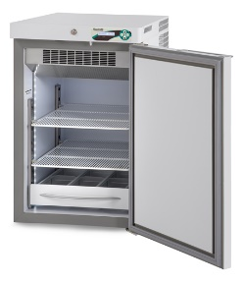  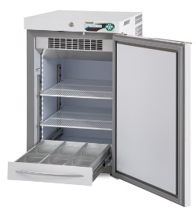  Disclaimer:  Images are purely indicative. The features and the accessories of the products may differ according to model and application. | Temperature range | Adjustable -20°C / -10 °C
 | Factory setpoint | Increment | -20°C | 0.1°C
 | Ambient working class | Climatic class | From +16°C to +32°C | N
 | Nominal capacity | 140 lt (4,94 cu ft)
 | Gross capacity | Net capacity | 153 lt (5,40 cu ft) | 128 lt (4,52 cu ft)
 | External dimensions (WxDxH) | 52x63,5x83 cm
 | Internal dimensions (WxDxH) | 44x51,6x56 cm
 | Net weight without any internal fittings | 51 kg
 | Package dimensions | Weight | Cardboard on pallet 55x69x100 cm | weight 59,5 kg
 |  | Wooden crate on pallet 60x77x103 cm | weight 69,5 kg
 | Structure | Monocoque type, made of plasticized, non-toxic white steel interior/exterior, coated with a special antibacterial-type film, or in inner 18/10 Aisi 304 stainless steel. Rounded corners and tray-type inner bottom,
 | Insulation type | High-density (43 kg/m³), in-walls injected PUF, without any CFC, water-foam based.
 | Insulation thickness | 40 mm
 | Feet | No.4 adjustable small feet
 | Door | No.1 solid door with ergonomic handle, self-closing thanks to the spring hinge and 90°stop position.
 | Lightning | Full LED, all length of inner chamber, automatic switching on at door opening.
 | Internal fittings | Customizable and height adjustable, it can mix independently:  wire shelves supported by adjustable clips (dim.cm.40x47)  fully extractible drawers made of aluminium, with dividers (WxDxH): cm 10x45x7,5 (nr 3 compartments)  fully extractible drawers made of aluminium, without dividers (WxDxH): cm 33x45x7,5
 | Suggested internal fittings | No. 2 wire shelves
 | Refrigeration system
 | Refrigeration | Professional, ventilated, forced, hermetic compressor type
 | Defrost | Automatic, adaptive, including condensate water vaporisation
 | Refrigerant | Natural R290
 | GWP | ODP | 3 | 0

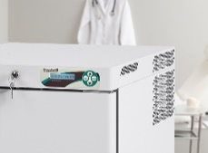 | Electronic controller
 | Controller | ECT-F PLUS controller
 | Type of controller | Electronic controller, back-lit alphanumeric LCD display and resolution 0,1°C
 | Power switch | Integrated in user’s interface
 | Security features | Settable user password
 | Alarm system | Visual and acoustic for temperature alarms and failures such as:  Open door  High temperature  High temperature caused by power failure.  Low temperature  Power failure (alarm back up up to 48h)  Clogged condenser  Faulty batteries  Any functional failure/faulty parts
 | Data and event recordings | Last 12 events available on the display
 | Settable temperature alarm limits | Yes, through parameter adjustment
 | Control sensors | NTC type probes
 | Connection for remote alarm signalisation | Ready on the board, remote on request
 | Temperature recording | Log of minimum and maximum temperature reached, manual reset
 | Data export | Not available
 | Electrical and functional data
 | Standard power supply | 230V / 1ph / 50Hz
 | Standard plug type | Schuko tipo “G”
 | Compressor protection | Overload Protector incluso
 | Power absorption/current | kW 0,5 (Amp 2,3)
 | Inrush current | Amp 6
 | Noise level | <40 dBA
 | Heat emission according to EN 12900 | W 155
 | Hold over time at 20°C ambient (air) | 1,6 h (from -20°C to 0°C)
 | Energy consumption at 20°C ambient | 3,7 kWh/24h
 | Conformity
 | Directives and regulations | Directive 2006/42/EC (Machine directive)  Directive 2011/65/EC (ROHS II)  Directive 2015/863/ EC (ROHS III)  Directive 2012/19/EC (RAEE)  Directive 2014/30/EC (EMC)  Directive 2014/35/EC (LVD)  Regulation (EU) 517-2014 (F-gas)  Regulation (EU) 1907-2006_REACH
 | Available certificate | CE
 | Application environment | Non-flammable, non-explosive, non-corrosive, with adequate air exchange

Accessories available on request

Lock with key

External dry contact
DIN 13277 conformity | Includes: key lock, buffer batteries for power failure alarm and external terminal board with dry contact

Temperature chart recorder

Additional wire shelf kit

Extractible drawer on telescopic slides

Extractible drawer without inner dividers on telescopic slides

Plexiglas front panel for extractible drawer

Castors kit with brakes

One-way small castors

35mm access port with stopper (no.1)

Port hole mm 15 (no.1)

No.1 PT100 sensor with free contacts

Non-standard plug and cable

Power220V/60Hz

Power 115V/60Hz

Mains voltage stabilizer

Wooden crate package

